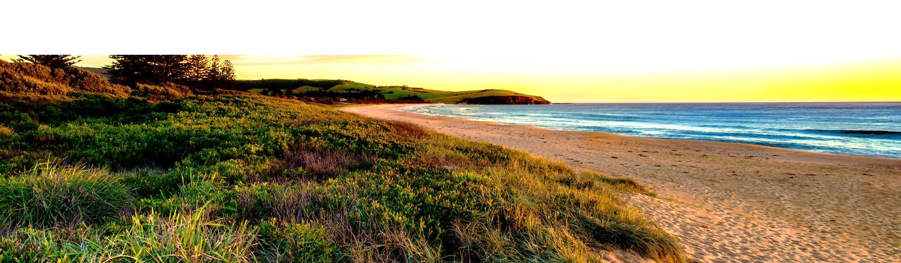
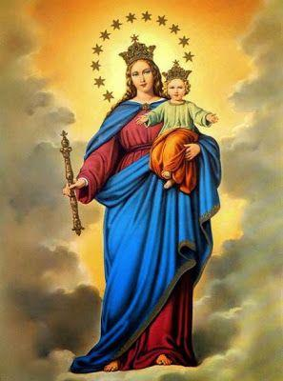
MARY HELP OF
CHRISTIANS
WALK FOR AUSTRALIA
WALK FOR LIFE
Friday, 20th May 2022

Praying for Australia and all life issues the day before the Federal Election.
You are warmly welcome to join us in our tenth year, praying along the Kiama Coastal Walk to Gerringong (13km).
B.Y.O lunch, snacks, water and hat.

PROGRAM:

Start 9:30am - Holy Mass at Sts Peter and Paul Catholic Church, Kiama.
10:30am - Coastal walk from Kiama Catholic Church to Our Lady Star of the Sea Catholic Church, Gerringong. 3:30pm – Benediction, Confession available.

Details
• Train from Sydney to Kiama (Nowra / Bomaderry line).
• Shuttle cars will be available for return to the start point.
• Support vehicle for tired pilgrims.
• Prayer booklets will be provided.

For information contact:
Sue Hill: 0435 336 195 or Gabriella De Battista: (02) 42 612500

BENEFITS: Mass. Prayer. Hymns. Exercise. Spectacular scenery. Blessings. Joy. Fellowship.

